**Location:** Online

**Date:** 26 October 2022

**Time:** 17:00 – 18:00 ET

**Attendance:** Dominic Benintendi, Drew Edmonds, Ian Gant, Aditya Sahi, Dan Allwine

**Not Attending**: Tianyi Cai

**Discussion:**

1. Project Scope:

In accordance with the last meeting's action items, each member did preliminary research on a specific topic they were assigned, and talked about it in front of the group

* 1. Ian: Driving mechanism for mirror (2 axis freedom)
     1. Spoke about a system including two galvanized motors
  2. Aditya: Laser options and driving circuits
     1. Offered a research paper on the topic of laser options and laser safety
  3. Dominic: Microcontroller and motor drive
     1. Talked about microcontroller and project scope
     2. 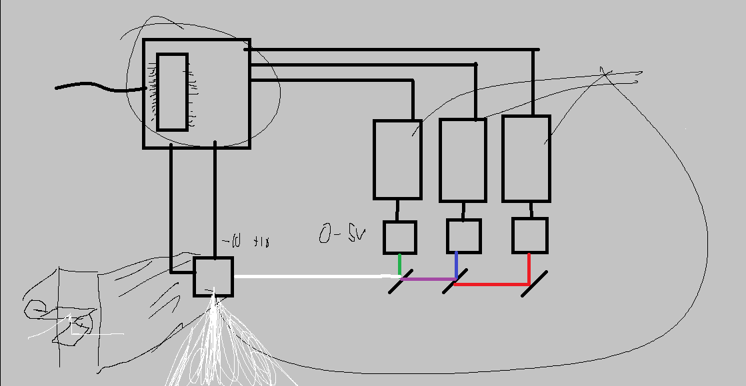
  4. Drew: General safety and rapid eye tracking
     1. Talked about the different classes of lasers

1. Safety discussion :

Dan made is clear that we should sacrifice project performance in the name of safety in the future, ergo, we should work with low wattage lasers if possible

1. Possible Scope

After confirming our desire to go down the laser projection route, We looked at several different avenues for the project to go.

* 1. How many colors?
  2. How many lasers?
  3. Moving images?
  4. Possible implementation with asteroids game

1. Budget
   1. Team will be given 500$ for our final version of the project
   2. Intermittent designs will not be counted towards the final projection
   3. We can also include the use of our own parts, but they cant be taken back mid development
2. Action Items:

By next monday, we need to do the following

* Finalize Major project scope, Where do we want to go with this?
* Everyone must give their ideas on the discord

1. Next Meeting: **17:00 ET – Tue, 1 Nov 2022 (Somewhere in ARC, if available)**